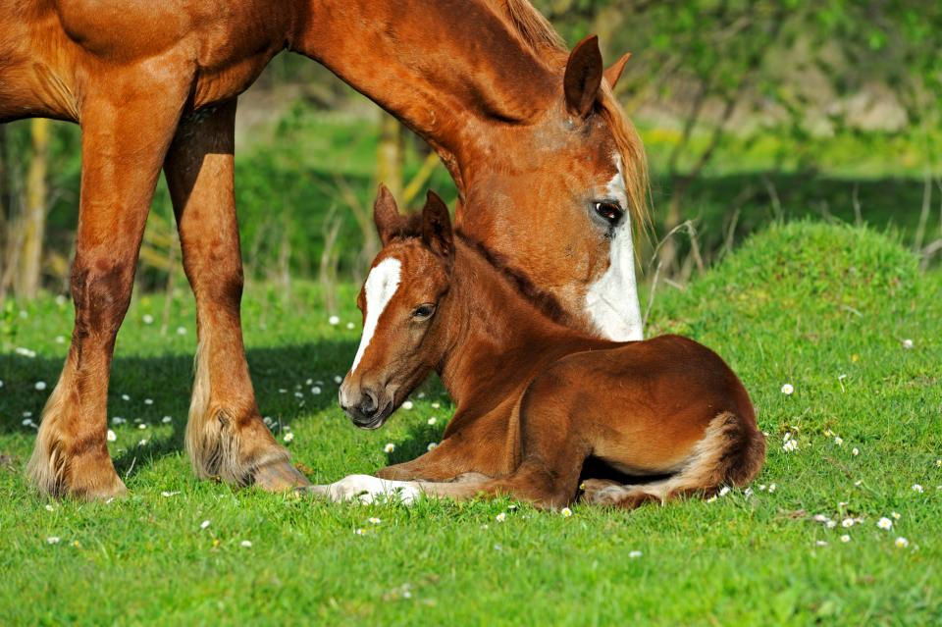
Open Position:
Theriogenology Dept. Administrative Assistant
Full Time: 5 Days a Week, Hours: 8:30-5:00pm – 1 weekend day included during breeding season
Primary Role: Duties include, but are not limited to, supporting a high-volume department by:
· Making appointments
· Organizing shipments
· Completing billing
· Client service
· Communication within department and outside the department
· Prepare reports as needed

Qualifications:
· Capable of multi-tasking and utilizing multi-line phone system
-Attention to detail
· Excellent computer skills - proficient with Microsoft Word and Excel
· Customer-focused
· Organization skills
· Effective communicator, communication competence a must!
· Ability to lift 40 lbs.
-Basic skills with Google Calendar

Experience:
In person Customer Service experience greater than 1 yr.
Equine experience preferrable in reproduction greater than a 1yr
Basic Equine & Medical terminology helpful

Please Submit Letter of Intent to: hr@roodandriddle.com

